SSD-TECH
CGW Application Manual

CGW Manual: 1.0
Created: 30 March 2018
Update: 13 May 2018

Systems Solutions and Development Technologies Sdn. Bhd.
Kuala Lumpur
Malaysia

Confidentiality: Distribution of this document is restricted. Holders of this document must ensure the confidentiality of the content and under no circumstances is this document to be shown or released to anyone without the prior consent of SSD-TECH.
Copyright: This document and its contents belongs to SSD-TECH it may not be copied, photocopied, scanned or redistributed without written consent from SSD-TECH.
Revision History
Revision Number | Date | Remarks | Introduced by
1.0 | 11 April 2018 | Incomplete Initial version. Done until Configuration items. | Raiyan Ferdous
2.0 | 30 April 2018 | Initial version | Md. Kamrul Hasan Shourov
3.0 | 03 May 2018 | Adding detailed result code description | Md. Kamrul Hasan Shourov
4.0 | 13 May 2018 | Changing graceful shutdown process mechanism | Md. Kamrul Hasan Shourov

Contents
1.0 Introduction 9
2.0 Executive Summary 9
3.0 System Architecture 9
4.0 CGW Application Requirements 9
5.0 CGW Configuration 10
Configuration Items 12
Server Specific configuration 12
CGWID 12
UserID 12
LISTENING_PORT 12
COMMAND_LISTENING_PORT 12
LOAD_PACKAGE_TABLE 13
NO_OF_THREADS 13
PARALLEL_BILLING_REQUEST 13
REGISTRATION_OUTPUT_ENABLED 13
CACHE_ENABLED_FOR_WALLET 13
RETRIEVE_SUBSCRIPTION_INFO_USING_IN_MEM_DB 13
CGW Request Transformation Configuration 14
DISCARD_PREFIX_OBD 14
CHECK_DISCARD_PREFIX_OBD 14
MSISDN_LENGTH 14
COUNTRY_CODE 14
Rate Plan Configuration 14
REFUND_SESSION 15
REGION_CHECK_ENABLE 15
CALL_TYPE_ID_CHECK 15
DIRECT_DIALING_CHECK 15
PACKAGE_RANGE_CHECK_ENABLE 16
PACKAGE_LOADING_AFTER 16
DefaultPackageID 16
MinPulseSize 16
DefaultTimeSlotId 16
DefaultCallTypeId 16
DefaultTPS 16
Persistent Database 16
HOST 17
PORT 17
USER 17
PASSWORD 17
DB 17
MAX_CONN 17
MAX_RETRY 17
In Memory Database 17
REDIS_HOST 17
REDIS_PORT 17
REDIS_PASSWORD 17
REDIS_DB 17
REDIS_MAX_CONN 17
REDIS_MAX_RETRY 18
Billing Interface Configuration 18
IN_INTEGRATED 18
DEFAULT_BILLING_HOST 18
DEFAULT_BILLING_PORT 18
PACKAGE_CHECK_ENABLED_SESSION 18
PACKAGE_CHECK_ENABLED_SPECIFIC 18
PACKAGE_CHECK_ENABLED_WITH_BALANCE 19
NUMBER_OF_RETRY_TO_FIND_PACKAGE 19
PACKAGE_HOST_IP 19
PACKAGE_HOST_PORT 19
RECV_TIMEOUT 19
SHOULD_USE_REMARKS 19
Log Configuration 19
LOG_LEVEL 20
LOG_FOR_ANY_MSISDN 20
LOG_INSTANCE 20
LOG_MSISDN 20
LOG_DIRECTORY 20
LOG_FILE_CREATION_INTERVAL 20
LOG_FILE_LINE_SEPARATOR 20
CDR Configuration 21
NUMBER_OF_CDR_PROCESSING_THREADS 21
CDR_WRITE_IN_FILE_ENABLE 21
IMMEDIATELY_SAVE_SUCCESS_CDR 21
CDR_DIRECTORY 21
CDR_FILE_CREATION_INTERVAL 21
CDR_DUPLICATION_CHECK_ENABLE 22
CDR_DUPLICATION_LAST_RESPONSE 22
INSERT_INTO_CRD_FOR_TPS 22
INSERT_INTO_CRD_FOR_ERROR_IN_APPID_OR_PASSWORD 22
CDR_FIELD_SEPARATOR 22
CDR_LINE_SEPARATOR 22
CDR_BATCH_SIZE 22
MySQL-Redis SYNC application (RDSS) configuration 22
SYNC_APP_QUEUE_NAME 23
SUBSCRIPTION_INFO_SEPARATOR 23
SUBSCRIPTION_INFO_KEY_PREFIX 23
SUBSCRIPTION_INFO_KEY_SEPARATOR 23
WALLET_INFO_VALUE_SEPARATOR 23
WALLET_INFO_KEY_PREFIX 23
WALLET_INFO_KEY_SEPARATOR 23
SECONDARY_WALLET_INFO_KEY_PREFIX 23
SECONDARY_WALLET_INFO_KEY_SEPARATOR 23
Log Server configuration 23
LOG_SERVER_MAX_CONTEXTS = 2000 23
LOG_SERVER_ENABLE 23
LOG_SERVER_IP 23
LOG_SERVER_PORT 24
LOG_SERVER_RECONNECT_INTERVAL 24
LOG_SERVER_CONCURRENT_SENDER 24
LOG_SERVER_MAX_CONTEXTS 24
6.0 Start CGW Application 24
7.0 Result codes 24
8.0 Result Code Description 25
2001 25
9004 25
9005 25
9010 25
9012 25
9016 25
9017 25
9021 25
9023 25
9024 25
9025 25
9028 26
9029 27
9030 27
9031 27
1012 27
9.0 Request format 27
CGW 27
Parameter description 27
Specific charge request 29
Session based request 29
IN Requester 29
Application interface 29
Web service interface 30
Parameter description 30
10.0 Response format 31
CGW 31
Format of response 31
Parameter description 31
IN Requester 32
11.0 Command Server 33
Sample table reloading 33
Sample configuration loading 34
Sample rate context 35
Sample rate information 35
Sample graceful shutdown process 36
Notes on CDR batch processing 36
12.0 Package finding steps 37
13.0 Package loading process 37
14.0 Package information finding from REDIS server 37

Terminologies
CBI Charging and billing interface
CGW Charging Gateway
IN Intelligent Network
RDSS Relational Database Syncing System
WS Web Services

Introduction
This document will define the SSD-TECH Charging Gateway (CGW) deployment and operational procedures. The Technology Operations team must comply to this document for successful deployment and operations of CGW Application.

Executive Summary
This version of CGW application uses REDIS as your primary storage and MySQL as your secondary storage. Here you can take full advantages of RDSS application. With RDSS, CGW application can avoid any direct communication with MySQL and save a huge time during each transaction and make itself more responsive and performant to the end users. (see “Utilize RDSS with your application” section for more details)

System Architecture
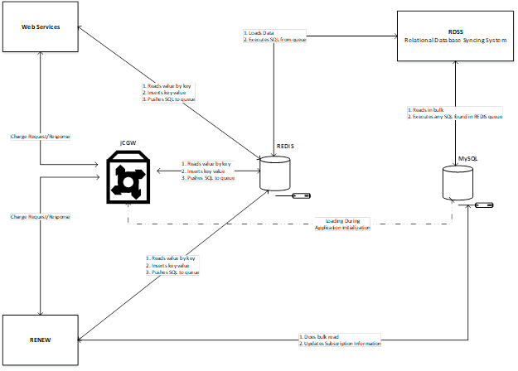

CGW Application Requirements
- JAVA 8
- MySQL 5.7.x
- REDIS 4.x.x

CGW Configuration
CGW is highly dependent on its configuration. The configuration must be written in <APPLICATION_ROOT>/ConfigurationFiles/cgw/cgw.ini file. It looks like [ This is the full version. Yellow background represents properties with default value. They will be hidden]:

[Server Specific configuration]
CGWID = 200
UserID = AdminISMP2.0V0.1.0
LISTENING_PORT = 3888
COMMAND_LISTENING_PORT = 2222
LOAD_PACKAGE_TABLE = 1
NO_OF_THREADS = 2000
PARALLEL_BILLING_REQUEST = 1
REGISTRATION_OUTPUT_ENABLED = 0
CACHE_ENABLED_FOR_WALLET=1
RETRIEVE_SUBSCRIPTION_INFO_USING_IN_MEM_DB = 0

[CGW Request Transformation Configuration]
DISCARD_PREFIX_OBD = 1
CHECK_DISCARD_PREFIX_OBD = 0
MSISDN_LENGTH = 10
COUNTRY_CODE = 880

[Rate Plan Configuration]
REFUND_SESSION = 1
REGION_CHECK_ENABLE = 0
CALL_TYPE_ID_CHECK = 0
DIRECT_DIALING_CHECK = 0
PACKAGE_RANGE_CHECK_ENABLE = 0
PACKAGE_LOADING_AFTER = 240
DefaultPackageID = Prepaid
MinPulseSize = 1
DefaultTimeSlotId = AnyTime
DefaultCallTypeId = AnyCall
DefaultTPS = 1000

[Database Configuration]
[Persistent Database]
HOST = localhost
PORT = 3306
USER = root
PASSWORD = nopass
DB = cgw_3_0_8
MAX_CONN = 100
MAX_RETRY = 2
[In Memory Database]
MEM_HOST = localhost
MEM_PORT = 6379
MEM_PASSWORD = foobared
MEM_DB = 0
MEM_MAX_CONN = 100
MEM_MAX_RETRY = 2

[Billing Interface Configuration]
IN_INTEGRATED = 1
DEFAULT_BILLING_HOST = localhost
DEFAULT_BILLING_PORT = 3650
PACKAGE_HOST_IP = 192.168.246.252
PACKAGE_HOST_PORT = 3650
PACKAGE_CHECK_ENABLED_SESSION = 0
PACKAGE_CHECK_ENABLED_SPECIFIC = 0
PACKAGE_CHECK_ENABLED_WITH_BALANCE = 0
NUMBER_OF_RETRY_TO_FIND_PACKAGE = 3
SHOULD_USE_REMARKS = 0
RECV_TIMEOUT = 5000

[Log Configuration]
LOG_LEVEL = 4
LOG_FOR_ANY_MSISDN = 0
LOG_INSTANCE = CGW1
LOG_MSISDN = 1823208399, 1922113354, 1944113354, 1966113354, 1988113354, 1959771233, 1913740177, 1933113354, 1977113354, 1999113354
LOG_DIRECTORY = E:/LogDirectory/cgw/logs
LOG_FILE_CREATION_INTERVAL = 600
LOG_FILE_LINE_SEPARATOR = [13, 10]

[CDR Configuration]
NUMBER_OF_CDR_PROCESSING_THREADS = 1
CDR_WRITE_IN_FILE_ENABLE = 1
IMMEDIATELY_SAVE_SUCCESS_CDR = 1
CDR_DIRECTORY = E:/LogDirectory/cgw/cdr
CDR_FILE_CREATION_INTERVAL = 10
CDR_DUPLICATION_CHECK_ENABLE = 1
CDR_DUPLICATION_LAST_RESPONSE = 0
INSERT_INTO_CRD_FOR_TPS = 1
INSERT_INTO_CRD_FOR_ERROR_IN_APPID_OR_PASSWORD = 1
CDR_FIELD_SEPARATOR = |
CDR_LINE_SEPARATOR = \r\n
CDR_BATCH_SIZE = 10

[MySQL-Redis SYNC application configuration]
SYNC_APP_QUEUE_NAME = rdss:queue
SUBSCRIPTION_INFO_SEPARATOR = \|
SUBSCRIPTION_INFO_KEY_PREFIX = 0$
SUBSCRIPTION_INFO_KEY_SEPARATOR = :
WALLET_INFO_VALUE_SEPARATOR = \|
WALLET_INFO_KEY_PREFIX = 1$
WALLET_INFO_KEY_SEPARATOR = :
SECONDARY_WALLET_INFO_KEY_PREFIX = 2$
SECONDARY_WALLET_INFO_KEY_SEPARATOR = :

[Log Server configuration]
LOG_SERVER_ENABLE = 0
LOG_SERVER_IP =
LOG_SERVER_PORT = 0
LOG_SERVER_CONNECT_TIMEOUT = 1000
LOG_SERVER_RECONNECT_INTERVAL = 1000
LOG_SERVER_CONCURRENT_SENDER = 0
LOG_SERVER_MAX_CONTEXTS = 2000

Configuration Items
The configuration items are described one by one below:

Server Specific configuration
This consists of the following values:
CGWID = 200
UserID = AdminISMP2.0V0.1.0
LISTENING_PORT = 3888
COMMAND_LISTENING_PORT = 2222
LOAD_PACKAGE_TABLE = 1
NO_OF_THREADS = 2000
PARALLEL_BILLING_REQUEST = 1
REGISTRATION_OUTPUT_ENABLED = 0
CACHE_ENABLED_FOR_WALLET=1
RETRIEVE_SUBSCRIPTION_INFO_USING_IN_MEM_DB = 0
The name/value pairs of are described below:

CGWID
Represents unique identification of this CGW application. This id will be directly inserted into CGWID column of cdrintegrated table. Please ensure unique value of this property if multiple CGW are being used.

UserID
Represents a user-friendly identification which value will be directly inserted into UserID column of cdrintegrated table. Default value: AdminISMP2.0V0.1.0

LISTENING_PORT
Listening port for incoming transaction request.

COMMAND_LISTENING_PORT
Listening port for administrative purposes. Follow section which administrative actions can be performed.

LOAD_PACKAGE_TABLE
The value represents whether the package table will be loaded in memory or not. Following values are possible:
- 1 – Enable
- 0 – Disable
Follow section for better understanding this property.

NO_OF_THREADS
Maximum number of threads that will be created at a time. If number of transactions at a time cross this value, then additional transactions will be discarded.

PARALLEL_BILLING_REQUEST
Parallelly handles multiple requests from the same TCP connection. If enabled, separate thread will be created to handle additional request from the same TCP connection, otherwise new requests from the same TCP connection will be queued for further processing.
This feature is not currently implemented in this version. By default, additional requests from the same TCP connection will be handled separately.]

REGISTRATION_OUTPUT_ENABLED
To Provide Subscription Status from CGWapp. Following values are possible:
- 1 – Enable
- 0 – Disable
For using .Net Subscription application, this should be 0 as this case is not handled in that application.

CACHE_ENABLED_FOR_WALLET
If enabled, retrieved wallet info upon call initiation will be used for the same session otherwise wallet info will be retrieved for every transaction.
Followings are possible values:
- 1 – Enabled
- 0 – Disabled
Default value: 1

RETRIEVE_SUBSCRIPTION_INFO_USING_IN_MEM_DB
Instead of querying into MySQL database, it will retrieve subscription and wallet information using IN memory database. Also, if enabled, wallet information will be updated only in IN memory database and an update query will be sent to RDSS to sync with wallet table in MySQL database. Following values are possible:
- 1 – Enable
- 0 – Disable

CGW Request Transformation Configuration
This type of configuration consists of the values like below:
DISCARD_PREFIX_OBD = 1
CHECK_DISCARD_PREFIX_OBD = 0
MSISDN_LENGTH = 10
COUNTRY_CODE = 880
The name/value pairs of are described below:

DISCARD_PREFIX_OBD

CHECK_DISCARD_PREFIX_OBD

MSISDN_LENGTH
These three properties will be acted together to trim outbound number. CHECK_DISCARD_PREFIX_OBD property will be used if trimming feature is needed. Following values are possible:
- 1 – Enable
- 0 – Disable
DISCARD_PREFIX_OBD will be the starting position for outbound number; DISCARD_PREFIX_OBD is following ZERO based indexing; that means first position of outbound number will be 0, next position will be 1, … etc.
MSISDN_LENGTH will be the maximum length of outbound number after trimming.
Following diagram explains the trimming procedure:
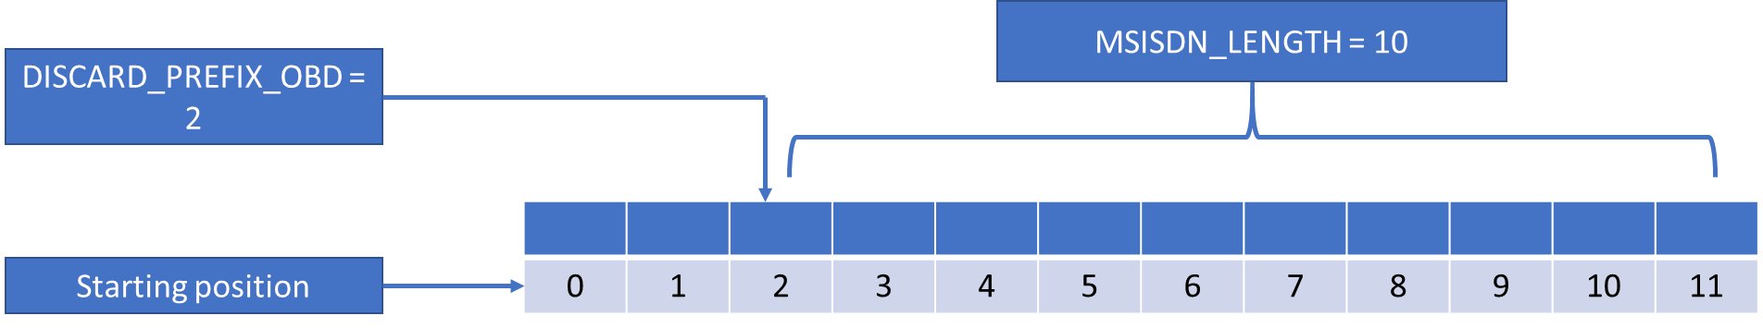

COUNTRY_CODE
This value will be appended ahead of requested MSISDN while constructing billing interface’s request. Follow section for billing interface’s request format.
Example: For Bangladeshi mobile number, COUNTRY_CODE = 880.

Rate Plan Configuration
This consists of the following values:
REFUND_SESSION = 1
REGION_CHECK_ENABLE = 0
CALL_TYPE_ID_CHECK = 0
DIRECT_DIALING_CHECK = 0
PACKAGE_RANGE_CHECK_ENABLE = 0
PACKAGE_LOADING_AFTER = 240
DefaultPackageID = Prepaid
MinPulseSize = 1
DefaultTimeSlotId = AnyTime
DefaultCallTypeId = AnyCall
DefaultTPS = 1000

REFUND_SESSION
Flag to indicate if refundable amount will be included into billing interface’s request format. Follow section for billing interface’s request format. Following values are possible:
- 1 – Enable
- 0 – Disable
Default value: 1

REGION_CHECK_ENABLE
Flag to indicate if region will be checked against region column of ratemaster table. regionurl table will be used to generate expected url.
Format: <hostname>:<port>/url
MSISDN and ServiceId will be appended by CGW.
Following values are possible:
- 1 – Enable
- 0 – Disable
Default value: 0

CALL_TYPE_ID_CHECK
Flag to indicate if CallTypeId column of table calltype value will be checked of not. Following values are possible:
- 1 – Enable
- 0 – Disable
Default value: 0

DIRECT_DIALING_CHECK
Flag to indicate if direct dialing feature is enabled at Call Handler end. If enabled, requested bno (See section to know about CGW request) will be matched against all short codes of subscriptiongroup table, returned that matched short code and treated as bno for further processing. Reason for this is that, Subscriber’s pressed options will be added with bno and if REDIS server is used for wallet information, then short code will be matched exactly with requested bno. Following values are possible:
- 1 – Enable
- 0 – Disable
Default value: 0

PACKAGE_RANGE_CHECK_ENABLE
If enabled, both StartMSISDN and EndMSISDN will be used while searching into package/specificpackage table using requested MSISDN, otherwise only StartMSISDN will be used. Following values are possible:
- 1 – Enable
- 0 – Disable
Default value: 0

PACKAGE_LOADING_AFTER
If LOAD_PACKAGE_TABLE is 1, then this field will try to reload package table next day after passing PACKAGE_LOADING_AFTER minutes from 12:00:00 AM.
If LOAD_PACKAGE_TABLE is 0, it will just re-set current package table prefix into application memory from REDIS server.

DefaultPackageID
This value will be used if no PackageID is found in package/specificpackage table.
Example: DefaultPackageID = Prepaid

MinPulseSize
Minimum allowed pulse size. This value will be used with steppulse column of ratepulse table to find desired pulse size. MinPulseSize value should be greater than 0.
$$Desired pulse size=MAX(MinPulseSize, steppulse)$$
Default value: 1

DefaultTimeSlotId
This value will be used if no TimeSlotID is set in timeslot table for requested application id.
Default value: AnyTime

DefaultCallTypeId
This value will be used if no CallTypeID is set in calltype table for requested ano and bno.
Default value: AnyCall

DefaultTPS
This value will be used if no tps limit is set in tps table for requested application id and timeslot id.
Default value: 1000

Persistent Database
These are used for MYSQL database configuration. Consists of the following values.
HOST = localhost
PORT = 3306
USER = root
PASSWORD = nopass
DB = cgw_3_0_8
MAX_CONN = 100
MAX_RETRY = 3

HOST
Server IP where CGW database has been deployed.

PORT
Database listening port.

USER
Database user name.

PASSWORD
Database user’s password.

DB
CGW database name. Current database name: cgw_3_0_8.

MAX_CONN
Maximum number of active Database connections.

MAX_RETRY
Maximum number of retry before a query execution will be treated as failed.

In Memory Database
Configuration values for in memory database(REDIS) information.
MEM_HOST = localhost
MEM_PORT = 6379
MEM_PASSWORD = foobared
MEM_DB = 0
MEM_MAX_CONN = 100
MEM_MAX_RETRY = 3

REDIS_HOST
Server IP where REDIS server has been installed.

REDIS_PORT
REDIS server listening port.

REDIS_PASSWORD
REDIS server’s password.

REDIS_DB
REDIS server DB index.

REDIS_MAX_CONN
Maximum number of active Database connections.

REDIS_MAX_RETRY
Maximum number of retry before a query execution will be treated as failed.

Billing Interface Configuration
Billing interface configuration consists of the following values:
IN_INTEGRATED = 1
DEFAULT_BILLING_HOST = localhost
DEFAULT_BILLING_PORT = 3650
PACKAGE_HOST_IP = 192.168.246.252
PACKAGE_HOST_PORT = 3650
PACKAGE_CHECK_ENABLED_SESSION = 0
PACKAGE_CHECK_ENABLED_SPECIFIC = 0
PACKAGE_CHECK_ENABLED_WITH_BALANCE = 0
NUMBER_OF_RETRY_TO_FIND_PACKAGE = 3
SHOULD_USE_REMARKS = 0
RECV_TIMEOUT = 5000
All the formats are explained below:

IN_INTEGRATED
Flag to indicate if IN Requester is integrated with CGW or not. Following values are possible:
- 1 – Enable
- 0 – Disable
This value largely depends on CGW building process. If no IN Requester is being integrated at building time, then setting 1 will not work. Consult the CGW team if you need IN Requester integrated CGW.

DEFAULT_BILLING_HOST
Default billing host if no billing node is found in billingnode table.
- Applicable only if IN_INTEGRATED is 0 and NULL/Empty value in BillingHost column (DB v3.0.6/v3.0.7) or URL (DB v3.0.4) of billingnode table.

DEFAULT_BILLING_PORT
Default billing port if not billing node is found in billingnode table.
- Applicable only if IN_INTEGRATED is 0 and NULL/Empty value in BillingHost column (DB v3.0.6/v3.0.7) or URL (DB v3.0.4) of billingnode table.

PACKAGE_CHECK_ENABLED_SESSION
Flag to indicate if package information will be queried at Operator end for session-based charging.
Following values are possible:
- 1 – Enable
- 0 – Disable

PACKAGE_CHECK_ENABLED_SPECIFIC
Flag to indicate if package information will be queried at Operator end for specific charging.
Following values are possible:
- 1 – Enable
- 0 – Disable

PACKAGE_CHECK_ENABLED_WITH_BALANCE
Flag to indicate if user’s current balance will be checked against deductible amount before sending transaction request to IN Requester.
Following values are possible:
- 1 – Enable
- 0 – Disable

NUMBER_OF_RETRY_TO_FIND_PACKAGE
How many times it will retry to find package. If integrated IN Requester is being used, then this value will be ignored.

PACKAGE_HOST_IP
Host address to query about subscriber’s balance and package id. If integrated IN Requester is being used, then this value will be ignored.

PACKAGE_HOST_PORT
Host port to query about subscriber’s balance and package id. If integrated IN Requester is being used, then this value will be ignored.

RECV_TIMEOUT
Timeout value while waiting to receive data from Socket interface. If integrated IN Requester is being used, then this value will be ignored.

SHOULD_USE_REMARKS
This field is used to determine whether the remarks field (11th field of the incoming request to CGW) would be used by CGW to form the request string to IN Requester. Follow section for CGW’s request format and section for billing interface’s request format. Following values are possible:
- 1 – Enable
- 0 – Disable

Log Configuration
This configuration values are used by the application for logging purpose. Values are like:
LOG_LEVEL = 4
LOG_FOR_ANY_MSISDN = 0
LOG_INSTANCE = CGW1
LOG_MSISDN = 1823208399, 1922113354, 1944113354, 1966113354, 1988113354, 1959771233, 1913740177, 1933113354, 1977113354, 1999113354
LOG_DIRECTORY = E:/LogDirectory/cgw/logs
LOG_FILE_CREATION_INTERVAL = 600
LOG_FILE_LINE_SEPARATOR = [13, 10]
Description of these values are given below:

LOG_LEVEL
Determines which level(s) of log will go to the destination. Followings are possible:
- 0 – OFF
- 1 – FATAL
- 2 – ERROR
- 3 – WARN
- 4 – INFO
- 5 – DEBUG
- 6 – ALL
- Other numeric value – DEBUG

LOG_FOR_ANY_MSISDN
Flag to indicate if transaction log is enabled for all MSISDNs. Followings are possible value:
- 1 – Enabled
- 0 – Disabled
If enabled, LOG_MSISDN values will be ignored

LOG_INSTANCE
Descriptive value that will be used while writing specific log for LOG_MSISDN.
Default value: CGW1

LOG_MSISDN
Separated formatted log will be generated for the specified MSISDNs. Every MSISDN will be separated by Comma (,). There is no limit about how many MSISDN can be used.
Example: LOG_MSISDN = 1830677123,1847184823,1858980299,1844170396,1844075152,1850666790

LOG_DIRECTORY
Directory where log is generated only for LOG_MSISDN. LOG_DIRECTORY must be created and must have write permission before running CGW application. Log file naming format:
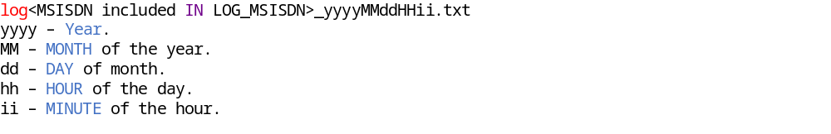
New log file will have generated after every 10 minutes for a specific MSISDN.

LOG_FILE_CREATION_INTERVAL
Time interval between two log file creation. Time unit: SECOND

LOG_FILE_LINE_SEPARATOR
Individual log line separator.
Default value: \r\n

CDR Configuration
CDR related configuration are added here. Sample key-values are:
NUMBER_OF_CDR_PROCESSING_THREADS = 1
CDR_WRITE_IN_FILE_ENABLE = 1
IMMEDIATELY_SAVE_SUCCESS_CDR = 1
CDR_DIRECTORY = E:/LogDirectory/cgw/cdr
CDR_FILE_CREATION_INTERVAL = 10
CDR_DUPLICATION_CHECK_ENABLE = 1
CDR_DUPLICATION_LAST_RESPONSE = 0
INSERT_INTO_CRD_FOR_TPS = 1
INSERT_INTO_CRD_FOR_ERROR_IN_APPID_OR_PASSWORD = 1
CDR_FIELD_SEPARATOR = |
CDR_LINE_SEPARATOR = \r\n
CDR_BATCH_SIZE = 10
Description of these values are given below:

NUMBER_OF_CDR_PROCESSING_THREADS
Total number of threads for CDR batch processing.
Note that, setting 0 (Zero) will disable CDR batch processing. Value greater than 0 (Zero) will store generated CDR into IN Memory DB.

CDR_WRITE_IN_FILE_ENABLE
If it is 1 then CDR will be written in File system instead of Database table. If 0, then CDR will be stored in cdrintegrated table. Following values are possible:
- 1 – Enable
- 0 – Disable

IMMEDIATELY_SAVE_SUCCESS_CDR
Flag to indicate if Success CDR will be immediately written into DB/File (Depends on CDR_WRITE_IN_FILE_ENABLE property value) instead of storing into IN Memory DB.
Note that, if NUMBER_OF_CDR_PROCESSING_THREADS contains 0 (Zero), then it’s value will be ignored.

CDR_DIRECTORY
Directory path where the CDR record files will be stored. CDR_DIRECTORY must be created and must have write permission before running CGW application

CDR_FILE_CREATION_INTERVAL
It will act as
- Time interval between two CDR file creation if CDR_WRITE_IN_FILE_ENABLE is 1.
- Sleep time between CDR batch processing if NUMBER_OF_CDR_PROCESSING_THREADS is greater than 0 (Zero) and CDR_WRITE_IN_FILE_ENABLE is 0.
Time unit: Second

CDR_DUPLICATION_CHECK_ENABLE
If set to 1 then CDR duplicate check will be done by CGW application. Otherwise if set to 0 then no duplicate checking will be done.

CDR_DUPLICATION_LAST_RESPONSE
If CDR_DUPLICATION_CHECK_ENABLE=1 and CDR_DUPLICATION_LAST_RESPONSE=1 then last response will be send for this duplicate CDR.

INSERT_INTO_CRD_FOR_TPS
If enabled, then CDR will be generated if TPS is exceed. Following values are possible:
- 1 – Enable
- 0 – Disable

INSERT_INTO_CRD_FOR_ERROR_IN_APPID_OR_PASSWORD
If enabled, then CDR will be generated if authentication failed. Following values are possible:
- 1 – Enable
- 0 – Disable

CDR_FIELD_SEPARATOR
Field separator.
Default value: |

CDR_LINE_SEPARATOR
Individual CDR separator.
Default value: \r\n

CDR_BATCH_SIZE
If NUMBER_OF_CDR_PROCESSING_THREADS >= 0 and CDR_WRITE_IN_FILE_ENABLE = 0, then at a time this number of CDR will be stored into database. Apart from this case, it’s value will be ignored.
Default value: 10

MySQL-Redis SYNC application (RDSS) configuration
Sample values are given below.
SYNC_APP_QUEUE_NAME = rdss:queue
SUBSCRIPTION_INFO_SEPARATOR = \|
SUBSCRIPTION_INFO_KEY_PREFIX = 0$
SUBSCRIPTION_INFO_KEY_SEPARATOR = :
WALLET_INFO_VALUE_SEPARATOR = \|
WALLET_INFO_KEY_PREFIX = 1$
WALLET_INFO_KEY_SEPARATOR = :
SECONDARY_WALLET_INFO_KEY_PREFIX = 2$
SECONDARY_WALLET_INFO_KEY_SEPARATOR = :
Description of the values are below:

SYNC_APP_QUEUE_NAME
The name of the RDSS queue where the MySQL queries are passed for execution. Please match this with the corresponding value of RDSS app config.json file.

SUBSCRIPTION_INFO_SEPARATOR
Default value: ‘\\|’

SUBSCRIPTION_INFO_KEY_PREFIX
This is the table prefix of subscriberservices table of CGW database. Match this with RDSS config.json and append an additional $ sign after it.

SUBSCRIPTION_INFO_KEY_SEPARATOR
Default value: ‘:’

WALLET_INFO_VALUE_SEPARATOR
Default value: ‘\\|’

WALLET_INFO_KEY_PREFIX
The prefix of wallet table. Match this value with RDSS config.json like SUBSCRIPTION_INFO_KEY_PREFIX.

WALLET_INFO_KEY_SEPARATOR
Default value: ‘:’

SECONDARY_WALLET_INFO_KEY_PREFIX
This is the prefix of another format of the wallet table. Also match this value with RDSS config file.

SECONDARY_WALLET_INFO_KEY_SEPARATOR
Default value: ‘:’

Log Server configuration
They are used for showing statistics of the application in a remote log server. CGW application sends its status data to that server in a certain interval. The values look like below:
LOG_SERVER_ENABLE = 0
LOG_SERVER_IP =
LOG_SERVER_PORT = 0
LOG_SERVER_CONNECT_TIMEOUT = 1000
LOG_SERVER_RECONNECT_INTERVAL = 1000
LOG_SERVER_CONCURRENT_SENDER = 0

LOG_SERVER_MAX_CONTEXTS = 2000

LOG_SERVER_ENABLE
Flag to indicate if log monitoring is enabled or not. Following values are possible:
- 1 – Enable
- 0 – Disable

LOG_SERVER_IP
Log server IP.

LOG_SERVER_PORT
Log server port.

LOG_SERVER_RECONNECT_INTERVAL
Maximum number of milliseconds to wait before re-connecting to Log server.
Default value: 1000

LOG_SERVER_CONCURRENT_SENDER
Maximum number of threads that will be used to send state context to Log server.
Default value: 0

LOG_SERVER_MAX_CONTEXTS
Maximum number of state context that CGW will store. Beyond that new state context will be dropped.
Default value: 2000

Start CGW Application
Execute following query in the command prompt/terminal to start CGW:
Current Major version: 1
Current Minor version: 4

Result codes
Below are the result codes that can be only generated by CGW. CGW also forwards IN Requester’s result codes. So, apart from below codes, any other codes will be treated as IN Requester’s codes.
Result Code | Description
2001 | Charging Success
9004 | Wrong Request Format
9005 | Wrong Response Format
9010 | DB Query Failed
9012 | Blank Amount Returned
9016 | MSISDN Invalid Package
9017 | Session Timeout
9021 | TPS limit is exceed.
9023 | ARI Server Disconnect
9024 | ARI Server Send Invalid Response
9025 | Duplicate CDR id is being detected.
9028 | No rate id found in the current context.
9029 | Wallet info parsing error while loading from session information.
9030 | No session information found for requested CDR Id.
9031 | No wallet configuration found in serviceinfo table.
1012 | Authentication Failed

Result Code Description

2001
Charging is successful.

9004
Wrong formatted request has been sent to CGW interface. Follow section to know about the request format of CGW interface.

9005
Wrong formatted response has been returned from IN Requester’s Billing interface. Follow section to know about the response format of IN Requester’s Billing interface.

9010
Database query execution failed after retrying MAX_RETRY times.

9012
There is no amount configuration found corresponding to the given rate id. Amount configuration is loaded from ratepulse table into CGW. Follow section to find out amount configuration.

9016
Package id “INVALID” is returned from Balance-package query interface. Currently only BanglaLink IN Requester returns this type of response.

9017
At session interim call, if wallet’s balance is finished then this result code will be generated.

9021
TPS [Transaction per second] will exceed the mentioned limit in value column of tps table for the mentioned application id and time slot id [TimeSlotID column of timeslot table].

9023
If IN Requester is not integrated, then socket communication will be used to connect balance-package query interface [Ex. ARI server]. If no socket connection can be established with ARI server, then this result code will be generated.

9024
Balance-package query interface’s response format is:
<Package Id>|<Balance>|<Result code>
If IN Requester return wrong formatted or insufficient response, then this result code will be generated.

9025
At successful transaction, a key-value is stored in REDIS server:
dcdr.<CDR id> -> “<CDR id> <Result code> <Charging type> <Sequence no> <PulseSize>”
Now, if another transaction will use the same CDR id, then this result code will occur.
Note that, a successful CDR id will be kept for 24 hours.

9028
No rate id found in the current context.
Context is described below:

First phase
- When CGW loads ratemaster table into application space, Current time is between ActivationStart and ActivationEnd columns.
- Service Id which is provided into CGW request should be matched with ServiceID column of ratemaster table.
- If subscription group id is provided into CGW request [It’s an optional parameter], then it will be matched with SubscriptionGroupID column of ratemaster table.
- Charging Type which is provided into CGW request should be matched with ChargingType column of ratemaster table.
- Package Id [Follow section to know how to find package id] should be matched with PackageID column of ratemaster table.
- Time slot id [Follow timeslot table to find TimeSlotId] should be matched with TimeSlotID column of ratemaster table.
- Call Type Id [Follow calltype table to find CallTypeID] should be matched with CallTypeID column of ratemaster table.

Second phase
- Query subscriberservices and wallet table to find current state of the subscriber.
Possible states:
- na -> 0
- deregistered -> 1
- registered -> 2
- registered no balance -> 3
- not registered balance -> 4
- ingraceperiod -> 5
This state will be matched with SubscriptionStatus column of ratemaster table. Note that, if SubscriptionStatus column contains ‘na’, then Subscriber’s current state will be ignored. Also, in this phase, query exception can be occurred. If this happens, then Subscriber’s current state will be unknown and rate id cannot be determined.

Third phase
- If subscription group id is not provided, then in Second phase, subscription group id will be retrieved. It should be matched with SubscriptionGroupID column of ratemaster table. Note that, if SubscriptionGroupID columns contains ‘na’, then retrieved SubscriptionGroupID will be ignored.
- RegisteredServices column of ratemaster table should be among subscriber’s current registered [Registered, InGracePeriod, RenewalFailed included] subscription group ids. Note that, if RegisteredServices columns contains ‘na’, then this checking will be ignored.
- If channel is provided/retrieved from subscriberservices table, then it will be matched with channel column of ratemaster table.
If any step is unmatched, then this result code will be generated.

9029
In session-based charging, a serialized session information is mapped against given CDR id in REDIS server. The serialization and deserialization are totally internal to CGW. So, if this result code occurs, consult with Developer.

9030
This result code will only generate for session-based charging requests. At session initiation, a serialized session information is mapped against given CDR id in REDIS server. Subsequent interim and stop requests will must need to use previously given CDR id at session initiation, otherwise this code will be given.

9031
No wallet configuration found in serviceinfo table.

1012
Either application id or application password is not matched with applicationid and passwd columns of applicationinfo table.

Request format

CGW
appid=<Application Id>&apppass=<Application password>&cmdid=<Charging type>&cmdparam=<ANO>|<BNO>|<Direction>|<Service Id>|<CDR Id>|<Sequence No>|<Consumed unit since last request>|<Remarks (Optional)>|<Subscription Group Id (Optional)>|<Channel (Optional)>

Parameter description
Parameter name | Description
Application Id | Authentication parameter. Given value should be matched with applicationid column of applicationinfo table. Case sensitive.
Application password | Authentication parameter. Given value should be matched with passwd column of applicationinfo table [Equality check will be done only if requirepass is TRUE]. Case sensitive.
Charging type | Indicate what type of transaction has been requested. Following charging types are possible:  - SPECIFIC_CHARGE  - SESSION_START  - SESSION_INTERIM  - SESSION_STOP  Note that, following mapping is used for Call handler:  - AUTH_CALL -> SESSION_START  - REAUTH_CALL -> SESSION_INTERIM  - END_CALL -> SESSION_STOP
ANO | Calling number/Subscriber’s mobile number.
BNO | Called number/Short code. Use ‘na’ if no BNO is needed.
Direction | It indicates between ANO and BNO which will be used to charge.  Two values are possible:  0 ----> ANO <- ANO, BNO <- BNO  1 ----> ANO <- BNO, BNO <- ANO
Service Id | ServiceID column of ratemaster table. Case insensitive.
CDR Id | Numeric or Alphanumeric id. Maximum length is 50.
Sequence No | For specific charge request, it will always be 0.  For session-based charge request, it will start from 0 and for every request within same session it’s value should be incremented by 1.
Consumed unit since last request | For specific charge request, it will always be 0.  For session-based charge request, it will indicate how many pulse have been allocated for previous charging request.  For SESSION_STOP request, this value will be used to refund balance.  $$Refundable Balance=Previously allocated pulse size-Consumed unit since last request$$
Remarks (Optional) | Remarks column of subscriptiongroup table. Case insensitive.
Subscription Group Id (Optional) | SubscriptionGroupID column of subscriptiongroup table. Case insensitive.
Channel (Optional) | It indicates which source transaction request has been came from. Case insensitive.

Specific charge request
appid=test&apppass=test&cmdid=SPECIFIC_CHARGE&cmdparam=1985996717|na|0|test|1234567891234567|0|0|na|test|na

Session based request
- Initiation
appid=test&apppass=test&cmdid=SESSION_START&cmdparam=1985996717|na|0|test|1234567891234567|0|0|
- Continuation
appid=test&apppass=test&cmdid=SESSION_INTERIM&cmdparam=1985996717|na|0|test|1234567891234567|0|60|
.
.
.
- Stop
appid=test&apppass=test&cmdid=SESSION_STOP&cmdparam=1985996717|na|0|test|1234567891234567|0|39|

IN Requester

Application interface
CDRID[ServiceID]|sequenceno|requesttype|ano|bno|direction|rateid|amount|consumedunitsincelastrequest|requestedUnit
Example
19645016012015120930[MusicDaily]|0|SPECIFIC_CHARGE|88001716033678|555|0|Music_Daily_subscription|100|0|180
If REFUND_SESSION is enable the request string is like
CDRID[ServiceID]|sequenceno|requesttype|ano|bno|direction|rateid|amount|consumedunitsincelastrequest|requestedUnit|refundAmount
Example
19645016012015123533[MusicDaily]|0|SPECIFIC_CHARGE|88001716033678|555|0|Music_Daily_subscription|100|0|180|0
If remarks are enabled, then remarks and applicationId separated by a space are also appended in the end.
CDRID[ServiceID]|sequenceno|requesttype|ano|bno|direction|rateid|amount|consumedunitsincelastrequest|requestedUnit|remarks applicationId
Example
701116042014110507[LSBNYB]|0|SESSION_START|8801778412765|2666|0|Info_100paisapermin_Registered|100|0|60|bl_ren_mwmw vsdp

Web service interface
chargingid=%s[%s]&sequenceno=%d&requesttype=%s&ano=%s&bno=%s&direction=%d&rateid=%s&amount=%d&consumedunitsincelastrequest =%d&pulseSize=%d
Example
chargingid=701116042014110507[LSBNYB]&sequenceno=0&requestType=SESSION_START&ano=8801778412765&bno=2666&direction=0&rateid=Info_100paisapermin_Registered&amount=100&consumedunitsincelastrequest=0&pulseSize=60
If remarks are enabled, then remarks and applicationId are also appended in the end.
chargingid=%s[%s]&sequenceno=%d&requesttype=%s&ano=%s&bno=%s&direction=%d&rateid=%s&amount=%d&consumedunitsincelastrequest =%d&pulseSize=%d&purpose=%s+%s
Example
chargingid=701116042014110507[LSBNYB]&sequenceno=0&requestType=SESSION_START&ano=8801778412765&bno=2666&direction=0&rateid=Info_100paisapermin_Registered&amount=100&consumedunitsincelastrequest=0&pulseSize=60&purpose=bl_ren_mwmw+vsdp

Parameter description
Parameter name | Description
CDRID | Unique ID for each request. It will be same for successive requests in session-based charging.
ServiceID | Denotes the service Id of the service. It is taken from the ServiceId field of RateMaster table.
SequenceNo | Sequence number will start from 0 and will increase for each interim request in session-based charging. It will be an integer.
RequestType | It will be one of SESSION_START, SESSION _INTERIM, SESSION _STOP, SPECIFIC_ CHARGE, SPECIFIC_RE CHARGE. Same as CmdId.
ANO | calling party number
BNO | called party number
Direction | charging direction of the call. If Direction is 0, ANO will be charged and if Direction is 1, BNO will be charged.
RateID | RateID for specific anounts
Amount | Amounts in 1/100 of paisa. 100 will mean 1 paisa.
ConsumedUnitSinceLastRequest | It is the consumed unit since the last interim charging request in session-based charging. It will be an integer.
RequestedUnit | It is the requested unit for charging. It is taken from the pulseSize column of the ratePulse table. In case of session-based charging, it is actually the time duration of the session in seconds. For specific charging, it is always 60.
Remarks(Optional) | Additional information for billing purpose needed by the operators. It is taken from the Remarks field of the SubscriptionGroup table if SHOULD_USE_REMARKS is set to 1 in the charging gateway config.ini file.
ApplicationId(Optional) | Application Id of the charging gateway taken from the configuration database.
refundAmount(Optional) | If REFUND_SESSION is enable, then refund is at the end of the request

Response format

CGW

Format of response
<TransactionID><SPACE><Resultcode><SPACE><SequenceNumber><SPACE><CommandId><SPACE><ReservedUnit><SPACE><SubscriptionStatus(Optional)>
**“<>” sign is used here to indicate the separation of fields. In the actual response string, the fields are separated only by a space.
Example
701116042014110507 2001 0 2 20

Parameter description
Parameter name | Description
TransactionID | CDR ID
Resultcode | Result code will be generated from two sources –  - CGW itself  - IN Requester  If result code is 2001, the charging is successful. Follow section for all allowable result code that can be generated from CGW itself.
Sequence Number | Sequence number sent by the requesting application.
Command Id | Apart from below mappings, same command Id sent by the requesting application will be used.  - AUTH_CALL -> SESSION_START  - REAUTH_CALL -> SESSION_INTERIM  - END_CALL -> SESSION_STOP  - CHARGE_SPECIFIC_AMOUNT -> SPECIFIC_CHARGE
ReservedUnit | Determines the unit reserved from the IN for session-based charging.
Subscription Status (Optional) | If REGISTRATION_OUTPUT_ENABLED is set to 1, then this field presents the subscription status. For, specific charging it’s always 0. For session based charging its values depend on the users’ registration status. If the user is registered, then it is 2 and if the user is deregistered then it is 1.

IN Requester
<TransactionId[ServiceType]> <ResultCode> <SequenceNumber> < CommandId> < ReservedUnit>
**“<>” sign is used here to indicate the separation of fields. In the actual response string, the fields are separated only by a space.
Example
19645008012015111501[MusicDaily] 2001 0 1 120
Or
19645008012015111501[MusicDaily] 2001 0 SPECIFIC_CHARGE 120
Parameter | Description
TransactionID | CDR ID
ServiceType | Denotes the service Id of the service. It is taken from the ServiceId field of RateMaster table.
Resultcode | If result code is 2001, the charging is successful.
Sequence Number | Sequence number sent by the requesting application
CommandId | cmdid or value for that cmdid. For SESSION_START=2, SESSION_INTERIM=3,SESSION_STOP=4, SPECIFIC_CHARGE=1,REFUND=5,BALANCE=6.
ReservedUnit | Determines the reservation unit for session-based charging.

Command Server
A formatted command can be sent to COMMAND_LISTENTING_PORT for administrative purposes. Following commands are allowed –
Command | Description
[reload]|[tables]|[table(s) name] | This command will reload table(s) that is/are already loaded by CGW at starting time. Allowable tables:  - applicationinfo  - tps  - billingnode  - timeslot  - ratemaster  - ratepulse  - subscriptiongroup  - calltype
[reload]|[|[conf]|[in] | This command will reload IN Requester’s configuration file. Note that, this command only applicable if IN Requester is integrated with CGW.
[show]|[data]|[ratecontext|(Service Id)|(SubscriptionGroupId)|(ChargingType)|(PackageId)] | This command will show rate context for given values.
[show]|[data]|[rateid|(Rate Id)] | This command will show rate information for given rateid (rateid column of ratepulse table).
[1] | For graceful shutdown purpose.

Sample table reloading

Single table reloading
reload|tables|applicationinfo
Loading table [applicationinfo]. OK.

Multiple table reloading
reload|tables|tps|ratemaster|calltype
Loading table [tps]. OK.Loading table [ratemaster]. OK.Loading table [calltype]. OK.

Note that,
- reload|tables|subscriptiongroup command will internally load three more tables:
- serviceinfo
- regionurl
- servicepayer
So, if any data has been changed in any of these tables, then reload|tables|subscriptiongroup command will need to be executed.
- If subscriptiongroup, ratemaster and ratepulse tables mentioned in the same command, then for consistency reason, these tables need to be followed the below order:
subscriptiongroup -> ratemaster -> ratepulse
reload|tables|subscriptiongroup|ratemaster|ratepulse

Wrong table reloading
reload|tables|subscriberservices
Loading table [subscriberservices]. Error.

Sample configuration loading
- IN Requester Integrated
reload|conf|in
Configuration loaded.

- IN Requester not integrated
reload|conf|in
Dummy BI contains no loadable configuration.

Sample rate context
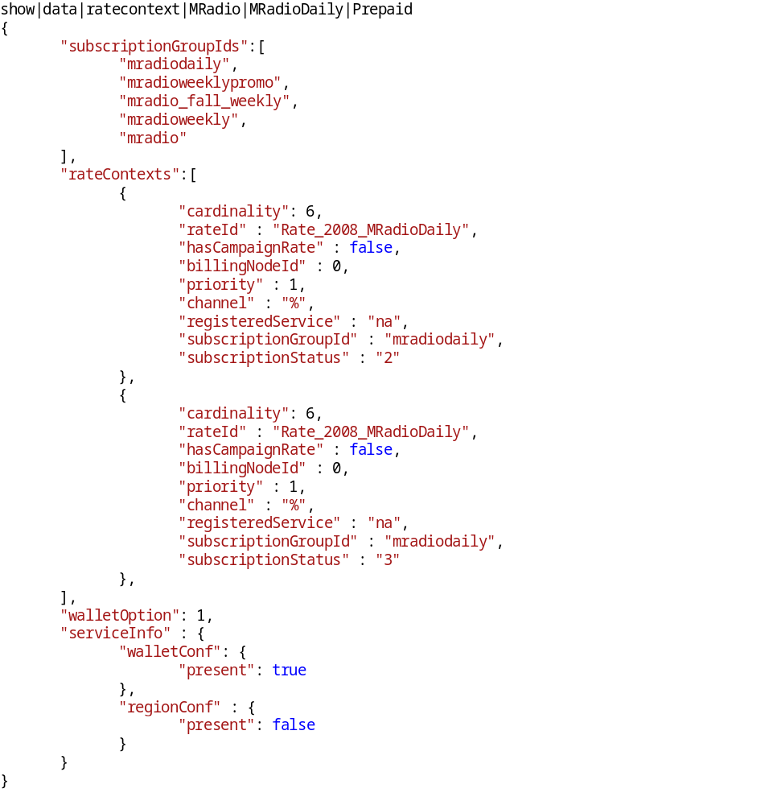

Sample rate information
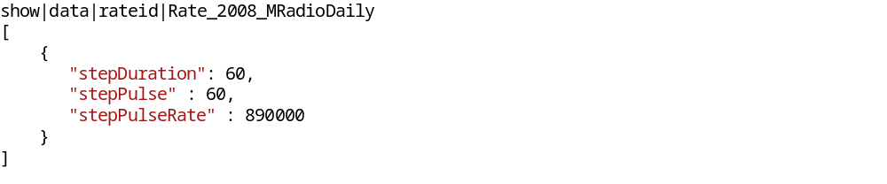

Sample graceful shutdown process
This action will activate graceful shutdown procedure –
- Stop listening server.
- Finish all pending transactions.
- Stop package loading thread.
- CDR batch processing thread will store pending CDRs into DB/File.
- Stop Log monitoring server.
- Cleaning all resources (DB connections, Http connections etc.).

Notes on CDR batch processing
If CDR batch processing is enabled, then gracefully shutdown is a MUST. If not, then at most NUMBER_OF_CDR_PROCESSING_THREADS x 1 seconds CDRs will be gone. So, reducing NUMBER_OF_CDR_PROCESSING_THREADS value will reduce the catastrophe, but you have make sure that NUMBER_OF_CDR_PROCESSING_THREADS value is enough to process generated CDRs. You can query into REDIS about pending CDRs -
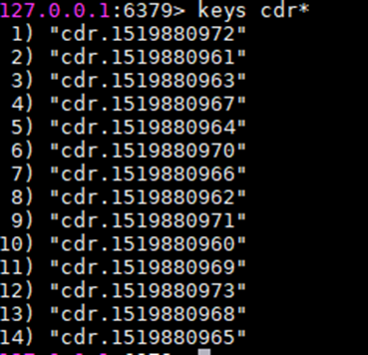

Package finding steps
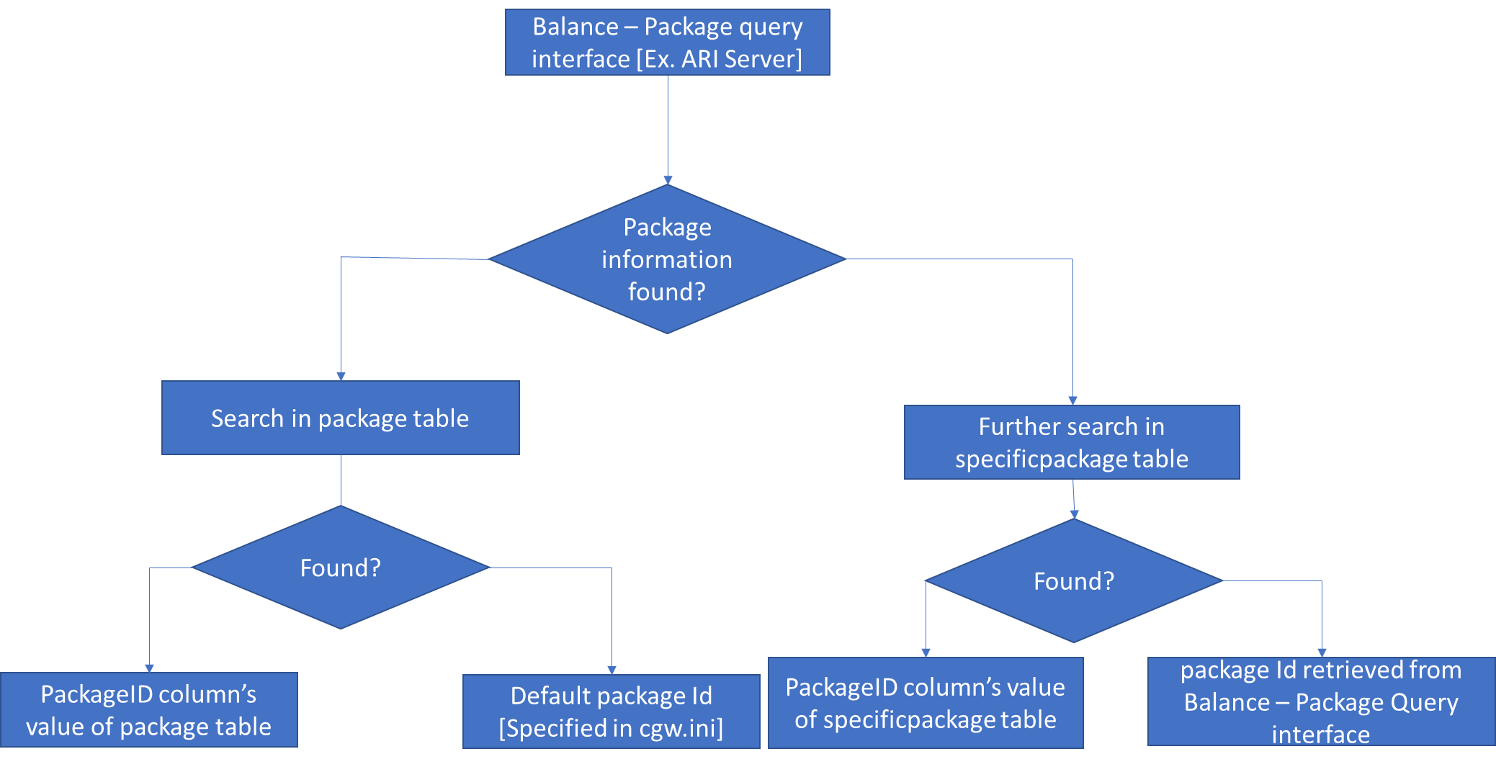
Follow section to know how to retrieve from REDIS server.

Package loading process
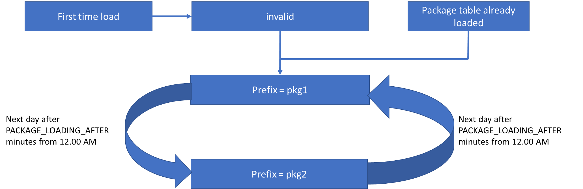

Package information finding from REDIS server
pkg_tbl_prefix key in Redis DB will hold the current package table prefix.
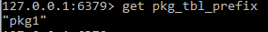
Retrieving data from package table:
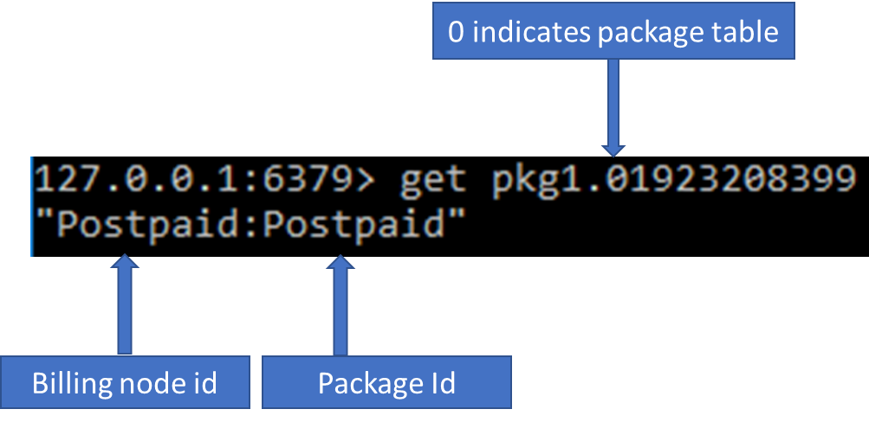

Retrieving data from specificpackage table:
